1614424

|  |  |  |  |  |  |  |  |  |
| --- | --- | --- | --- | --- | --- | --- | --- | --- |
| Input Data | |  |  |  |  |  |  |  |
|  |  |  |  |  |  |  |  |  |
| Species | | totage | topht | den | ps | ba | utilization | |
| AW |  | 41.0 | 6.24 | 817 |  | 7.2 | 13/7/30 | |
| SB |  |  |  |  |  |  | 15/10/30 | |
| SW |  | 45.0 | 6.24 | 123 |  | 1.09 | 13/7/30 | |
| PL |  | 32.0 | 6.24 | 297 |  | 2.62 | 13/7/30 | |
|  |  |  |  |  |  |  |  |  |
| Calculated Attributes | | |  |  |  |  |  |  |
|  |  |  |  |  |  |  |  |  |
| Species | | bhage | y2bh | si_bh | si_t | n0 | sdf | psi |
| AW |  | 32.3 | 8.7 | 8.4 | 7.4 | 986 | 668 |  |
| SB |  |  |  |  |  |  |  |  |
| SW |  | 30.6 | 14.4 | 9.3 | 7.0 | 123 | 123 |  |
| PL |  | 21.7 | 10.3 | 11.3 | 9.7 | 297 | 295 |  |
|  |  |  |  |  |  |  |  |  |
|  | | |  |  |  |  |  |  |

Tesera Gypsy

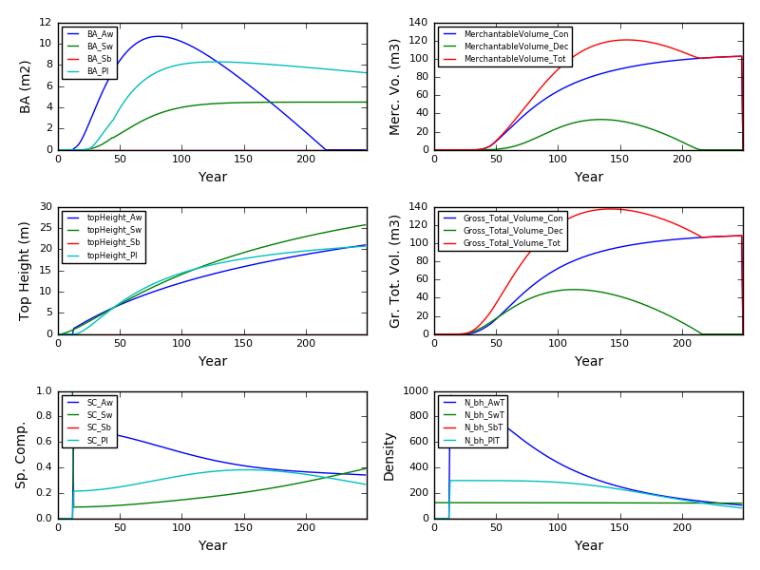

Excel Gypsy

